SIMATS ENGINEERING

CO2 - AT2 - Schema Analysis

NAME:A.PAVITHRA
REG NO:192424347
COURSE NAME: Query Processing For Data Analysis
CODE: DSA0503

Question 1: Student Course Registration Database (10 Marks)
A university maintains the following database schema:
• Student (Student_ID, Student_Name, Department, Year)
• Course (Course_ID, Course_Name, Credits)
• Enrollment (Enrollment_ID, Student_ID, Course_ID, Semester)
Here, Student_ID in the Enrollment table is a foreign key referencing the Student table, and Course_ID is a foreign key referencing the Course table.
Analyze the above schema and write a Python program using SQLite/MySQL/PostgreSQL to connect to the database and retrieve the names of all students along with the courses they are enrolled in during the "Odd 2026" semester using an appropriate SQL JOIN query.

CODE:

import sqlite3

# Connect to SQLite database
conn = sqlite3.connect("university.db")
cursor = conn.cursor()

# Create tables and insert sample data if they don't exist
cursor.execute("DROP TABLE IF EXISTS Student;")
cursor.execute("DROP TABLE IF EXISTS Course;")
cursor.execute("DROP TABLE IF EXISTS Enrollment;")

cursor.execute("""
CREATE TABLE Student (
Student_ID INTEGER PRIMARY KEY,
Student_Name TEXT NOT NULL
);
""")

cursor.execute("""
CREATE TABLE Course (
Course_ID INTEGER PRIMARY KEY,
Course_Name TEXT NOT NULL
);
""")

cursor.execute("""
CREATE TABLE Enrollment (
Enrollment_ID INTEGER PRIMARY KEY,
Student_ID INTEGER,
Course_ID INTEGER,
Semester TEXT NOT NULL,
FOREIGN KEY (Student_ID) REFERENCES Student(Student_ID),
FOREIGN KEY (Course_ID) REFERENCES Course(Course_ID)
);
""")

# Insert sample data
cursor.execute("INSERT INTO Student (Student_ID, Student_Name) VALUES (1, 'Alice');")
cursor.execute("INSERT INTO Student (Student_ID, Student_Name) VALUES (2, 'Bob');")
cursor.execute("INSERT INTO Student (Student_ID, Student_Name) VALUES (3, 'Charlie');")

cursor.execute("INSERT INTO Course (Course_ID, Course_Name) VALUES (101, 'History I');")
cursor.execute("INSERT INTO Course (Course_ID, Course_Name) VALUES (102, 'Math II');")
cursor.execute("INSERT INTO Course (Course_ID, Course_Name) VALUES (103, 'Physics I');")

cursor.execute("INSERT INTO Enrollment (Student_ID, Course_ID, Semester) VALUES (1, 101, 'Odd 2026');")
cursor.execute("INSERT INTO Enrollment (Student_ID, Course_ID, Semester) VALUES (1, 102, 'Even 2026');")
cursor.execute("INSERT INTO Enrollment (Student_ID, Course_ID, Semester) VALUES (2, 101, 'Odd 2026');")
cursor.execute("INSERT INTO Enrollment (Student_ID, Course_ID, Semester) VALUES (3, 103, 'Odd 2026');")

conn.commit()

# JOIN query
query = """
SELECT Student.Student_Name, Course.Course_Name
FROM Student
JOIN Enrollment
ON Student.Student_ID = Enrollment.Student_ID
JOIN Course
ON Enrollment.Course_ID = Course.Course_ID
WHERE Enrollment.Semester = 'Odd 2026';
"""

# Execute query
cursor.execute(query)

# Display results
print("Students and their Courses - Odd 2026")
print("--------------------------------------")

for row in cursor.fetchall():
print("Student Name:", row[0], "| Course:", row[1])

# Close connection
conn.close()

OUTPUT:

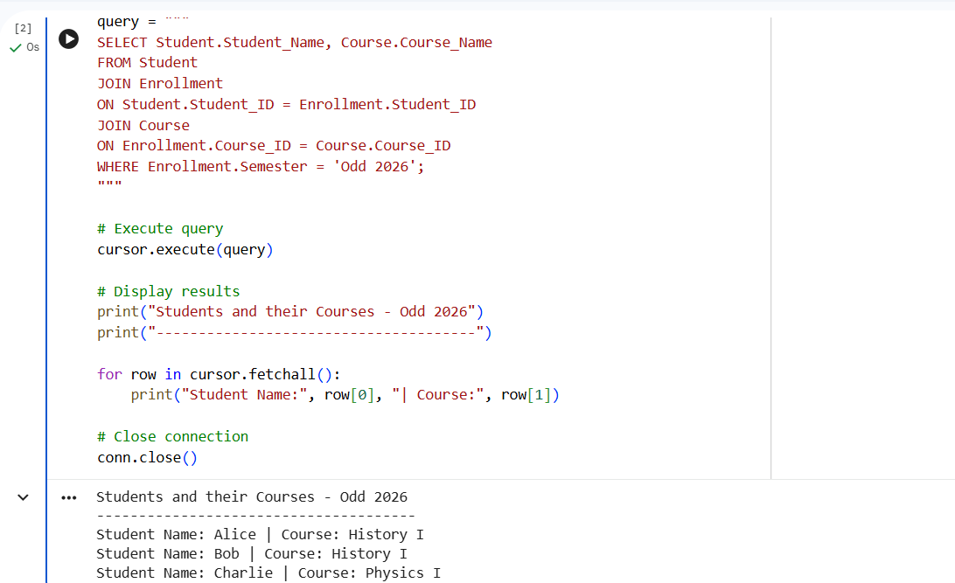

Question 2: Hospital Management Database (10 Marks)
A hospital maintains the following database schema:
• Doctor (Doctor_ID, Doctor_Name, Specialization)
• Patient (Patient_ID, Patient_Name, Age)
• Appointment (Appointment_ID, Patient_ID, Doctor_ID, Appointment_Date)
Analyze the schema and write a Python program to connect to the database and display the patient names, doctor names, and appointment dates for all appointments scheduled after 1 January 2026.

CODE:

import sqlite3

# Connect to SQLite database
conn = sqlite3.connect("hospital.db")
cursor = conn.cursor()

# Create tables and insert sample data if they don't exist
cursor.execute("DROP TABLE IF EXISTS Patient;")
cursor.execute("DROP TABLE IF EXISTS Doctor;")
cursor.execute("DROP TABLE IF EXISTS Appointment;")

cursor.execute("""
CREATE TABLE Patient (
Patient_ID INTEGER PRIMARY KEY,
Patient_Name TEXT NOT NULL
);
""")

cursor.execute("""
CREATE TABLE Doctor (
Doctor_ID INTEGER PRIMARY KEY,
Doctor_Name TEXT NOT NULL
);
""")

cursor.execute("""
CREATE TABLE Appointment (
Appointment_ID INTEGER PRIMARY KEY,
Patient_ID INTEGER,
Doctor_ID INTEGER,
Appointment_Date TEXT NOT NULL,
FOREIGN KEY (Patient_ID) REFERENCES Patient(Patient_ID),
FOREIGN KEY (Doctor_ID) REFERENCES Doctor(Doctor_ID)
);
""")

# Insert sample data
cursor.execute("INSERT INTO Patient (Patient_ID, Patient_Name) VALUES (1, 'John Doe');")
cursor.execute("INSERT INTO Patient (Patient_ID, Patient_Name) VALUES (2, 'Jane Smith');")
cursor.execute("INSERT INTO Patient (Patient_ID, Patient_Name) VALUES (3, 'Peter Jones');")

cursor.execute("INSERT INTO Doctor (Doctor_ID, Doctor_Name) VALUES (101, 'Dr. Alice');")
cursor.execute("INSERT INTO Doctor (Doctor_ID, Doctor_Name) VALUES (102, 'Dr. Bob');")

cursor.execute("INSERT INTO Appointment (Patient_ID, Doctor_ID, Appointment_Date) VALUES (1, 101, '2026-01-15');")
cursor.execute("INSERT INTO Appointment (Patient_ID, Doctor_ID, Appointment_Date) VALUES (2, 102, '2025-12-20');")
cursor.execute("INSERT INTO Appointment (Patient_ID, Doctor_ID, Appointment_Date) VALUES (1, 102, '2026-02-01');")
cursor.execute("INSERT INTO Appointment (Patient_ID, Doctor_ID, Appointment_Date) VALUES (3, 101, '2026-03-10');")

conn.commit()

# JOIN query
query = """
SELECT Patient.Patient_Name,
Doctor.Doctor_Name,
Appointment.Appointment_Date
FROM Appointment
JOIN Patient
ON Appointment.Patient_ID = Patient.Patient_ID
JOIN Doctor
ON Appointment.Doctor_ID = Doctor.Doctor_ID
WHERE Appointment.Appointment_Date > '2026-01-01';
"""

# Execute query
cursor.execute(query)

# Display results
print("Appointments after 1 January 2026")
print("---------------------------------")

for row in cursor.fetchall():
print("Patient:", row[0],
"| Doctor:", row[1],
"| Date:", row[2])

# Close connection
conn.close()

OUTPUT:

